# A Report

# on

# Leveraging Crowd-Sourced Data for Mapping and Analyzing Water-Related Issues within affected regions

***Submitted by,***

|  |  |
| --- | --- |
| **Ms. M KRITHI** | **20211CSG0018** |
| **Mr. PRANAV S** | **20211CSG0008** |
| **Mr. KARTHIKEYAN C** | **20211CSG0044** |
| **Mr. YOGESH CHAVAN** | **20211CSG0054** |

### *Under the guidance of,*

**Dr Chandrasekar Vadivelraju**

***in partial fulfillment for the award of the degree of***

**BACHELOR OF TECHNOLOGY**

**IN**

**COMPUTER SCIENCE AND TECHNOLOGY**

**At**



**PRESIDENCY UNIVERSITY**

**BENGALURU**

**DECEMBER 2024**





**ABSTRACT**

Water-related issues such as urban flooding, drainage blockages, and declining water quality are becoming increasingly critical, especially in densely populated areas. Traditional monitoring systems like remote sensing and fixed ground sensors often face limitations in terms of cost, coverage, and response time. Meanwhile, the widespread use of smartphones and social media platforms has enabled citizens to capture and share real-time, ground-level information during such events. This paper introduces a mobile application designed to crowdsource geo-referenced images of water-related problems from the public, analyze them using deep learning techniques, and display the results on an interactive map.

The app enables users to upload images of local water issues or extracts relevant publicly shared images from social media. These images are processed using a convolutional neural network (CNN) to categorize the problem into predefined classes such as flooding, waterlogging, pollution, or drainage failure. The app then visualizes the categorized reports on a map to provide a real-time overview of the situation in a given area.

Developed using Flutter for cross-platform accessibility, the app integrates a deep learning model and cloud-based backend to support automated analysis and storage. This system empowers emergency responders, municipal authorities, and planners by offering timely insights for intervention and long-term infrastructure planning. Moreover, the mobile app's open-data approach supports transparency and research collaboration.

By leveraging citizen participation and artificial intelligence, this project bridges the gap between traditional water monitoring systems and real-world, on-the-ground conditions. The application stands as a valuable tool in disaster management, environmental monitoring, and smart city planning, promoting a participatory approach to urban resilience.

**ACKNOWLEDGEMENT**

First of all, we indebted to the **GOD ALMIGHTY** for giving me an opportunity to excel in our efforts to complete this project on time.

We express our sincere thanks to our respected Dean **Dr. Md. Sameeruddin Khan**, Pro-VC, School of Engineering and Dean, Presidency School of Computer Science Engineering & Information Science, Presidency University for getting us permission to undergo the project.

We express our heartfelt gratitude to our beloved Associate Dean **Dr. Mydhili Nair,** Presidency School of Computer Science Engineering & Information Science, Presidency University, and **Dr. Saira Banu Atham**, Head of the Department, School of Computer Science Engineering & Information Science, Presidency University, for rendering timely help in completing this project successfully.

We are greatly indebted to our guide and Reviewer **Dr Chandrasekar Vadivelraju, Professor,** PresidencySchool of Computer Science Engineering, Presidency University for her inspirational guidance, and valuable suggestions and for providing us a chance to express our technical capabilities in every respect for the completion of the project work.

We would like to convey our gratitude and heartfelt thanks to the PIP4004 Capstone Project Coordinators **Dr. Sampath A K, Dr. Abdul Khadar A and Mr. Md Zia Ur Rahman,** department Project Coordinators **Dr. Manjula H M** and Git hub coordinator **Mr. Muthuraj.**

We thank our family and friends for the strong support and inspiration they have provided us in bringing out this project.

**1. Ms. M KRITHI**

**2. Mr. PRANAV S**

**3. Mr. KARTHIKEYAN C**

**4. Mr. YOGESH CHAVAN**

**LIST OF SCREEENSHOTS**

|  |  |  |  |
| --- | --- | --- | --- |
| **Sl. No.** | **Screenshot Name** | **Caption** | **Page No.** |
| 1 | Screenshot B.1 | Login page | 38 |
| 2 | Screenshot B.2 | Home page | 39 |
| 3 | Screenshot B.3 | Queries page | 39 |
| 4 | Screenshot B.4 | Report page | 40 |
| 5 | Screenshot B.5 | Dashboard | 40 |
| 6 | Screenshot B.6 | Home Screen | 41 |
| 7 | Screenshot B.7 | Analytics and Insights page | 41 |
| 8 | Screenshot B.8 | Maps | 42 |

**LIST OF FIGURES**

|  |  |  |  |
| --- | --- | --- | --- |
| **Sl. No.** | **Figure Name** | **Caption** | **Page No.** |
| 1 | Figure 1 | System design | 15 |
| 2 | Figure 2 | Gantt chart | 20 |
|  |  |  |  |
|  |  |  |  |
|  |  |  |  |
|  |  |  |  |
|  |  |  |  |
|  |  |  |  |
|  |  |  |  |
|  |  |  |  |

**TABLE OF CONTENTS**

|  |  |  |
| --- | --- | --- |
| **CHAPTER NO.** | **TITLE** | **PAGE NO.** |
|  |  |  |
|  | **CERTIFICATE** | ii |
|  | **DECLARATION** | iii |
|  | **ABSTRACT** | iv |
|  | **ACKNOWLEDGMENT** | v |
|  | **LIST OF SCREENSHOTS** | vi |
|  | **LIST OF FIGURES** | vii |
|  |  |  |
| **1.** | **INTRODUCTION** | 2 |
|  | 1.1 Why is this approach necessary | 3 |
|  | 1.2 What is crowd-sourced data | 3 |
|  | 1.3 Why focus on affected areas | 4 |
|  | 1.4 How can data lead to real change | 4 |
|  |  |  |
| **2.** | **LITERATURE SURVEY** | 5 |
|  | 2.1 Citizen-Contributed Geo-Referenced Data in Disaster Response | 5 |
|  | 2.2 Mobile Applications for Environmental Monitoring | 5 |
|  | 2.3 Computer Vision for Detection of Water-Related Issues | 6 |
|  | 2.4 Deep Learning in Environmental Image Classification | 6 |
|  | 2.5 Visualization and Decision Support Systems | 6 |
|  |  |  |
| **3.** | **RESEARCH GAPS OF EXISTING METHODS** | 7 |
|  | 3.1 A Lack of Ground-Level Geo-Referenced Data | 7 |
|  | 3.2 No Automated Image-Based Classification in Current Platforms | 7 |
|  | 3.3 Weak Integration of Mobile Platforms and AI-Based Backends | 7 |
|  | 3.4 Lack of Map-based Visualization Tools for Decision Makers | 8 |
|  | 3.5 Limited Capacity to Operate in Low Bandwidth or Offline Scenarios | 8 |
|  |  |  |
| **4.** | **PROPOSED METHODOLOGY** | 9 |
|  | 4.1 Data Collection and Annotation | 9 |
|  | 4.2 Model Development | 9 |
|  | 4.3 App and Web Development | 10 |
|  | 4.4 Backend & API Integration | 10 |
|  | 4.5 Testing and Evaluation | 11 |
|  | 4.6 Visualization and Reporting | 11 |
|  |  |  |
| **5.** | **OBJECTIVES** | 12 |
|  | 5.1 Build a simple mobile site | 12 |
|  | 5.2 AI-Enabled Image Classifications | 12 |
|  | 5.3 Web Dashboard: | 13 |
|  | 5.4 Backend Development | 13 |
|  | 5.5 Visualization and Insight Generation | 13 |
|  | 5.6 Community Participation, | 14 |
|  | 5.7 Long-term Scalability and Sustainability | 14 |
|  |  |  |
| **6.** | **SYSTEM DESIGN & IMPLEMENTATION** | 15 |
|  | 6.1 Components of the Jal Dristi System | 16 |
|  | 6.2 SYSTEM DESIGN PRINCIPLES | 18 |
|  | 6.3 Implementation Plan | 18 |
|  | 6.4 Challenges to Implementation | 19 |
|  | 6.5 Expected Results | 19 |
|  |  |  |
| **7.** | **TIMELINE FOR EXECUTION OF PROJECT** | 20 |
|  |  |  |
| **8.** | **OUTCOMES** | 23 |
|  | 8.1 Environmental Outcomes | 23 |
|  | 8.2 Economic impacts | 24 |
|  | 8.3 Social impacts | 24 |
|  | 8.4 Technology Outcomes | 25 |
|  | 8.5 Sustainability Without Limits | 25 |
|  |  |  |
| **9.** | **RESULTS AND DISCUSSIONS** | 27 |
|  | 9.1 System Performance | 27 |
|  | 9.2 Economic Evaluation Cost Effectiveness of Monitoring | 28 |
|  | 9.3 Environmental Impact Timely Identification of Hazards | 28 |
|  | 9.4 Social and Community Impact | 29 |
|  | 9.5 Challenges and Limitations | 29 |
|  |  |  |
| **10.** | **CONCLUSION** | 31 |
|  | 10.1 Environmental Sustainability | 31 |
|  | 10.2 Economic Benefits | 31 |
|  | 10.3 Social Impact | 32 |
|  | 10.4 Technological Innovation | 32 |
|  | 10.5 Challenges and Recommendations | 32 |
|  | 10.6 Way forward | 33 |
|  |  |  |
| **11.** | **REFERENCES** | 34 |
| **12.** | **APPENDICES** | 36 |
|  | APPENDIX-A: PSEUDOCODE | 36 |
|  | APPENDIX-B: SCREENSHOTS | 38 |
|  | APPENDIX-C: ENCLOSURES | 43 |
|  | 1 Certificate | 43 |
|  | 2 Sustainable Development Goals | 48 |
|  | 3 Similarity Index / Plagiarism Check | 50 |

**CHAPTER-1**

**INTRODUCTION**

Water is one of the most important natural resources on the planet. It is a life source, sustains ecosystems, and is essential for agriculture, industry, and health systems. Unfortunately, many areas in the world are currently dealing with a wide range of water issues including scarcity, contamination, poor supply infrastructure, and the impacts of floods and droughts. These problems are worsened by increased population growth, climate change, urbanization, and poor resource management. To sufficiently address and understand these water issues, accurate, timely, and location-specific data are essential. However, standard data collection approaches—which are primarily based on government agency and scientific research—tend to be slow, limited in scope, and inaccessible to local communities.

As a solution to the limitations of conventional data approaches, crowd sourcing data is a viable and innovative option. When the information comes directly from individuals and communities that are affected by water issues, there is the potential for timely, ground-level data, which can supplement official data sources. Citizen reporting on water leaks in their neighbourhood; mapping of flood-prone areas through mobile apps; or social media photographs of contaminated water are a few instances of how crowd-sourced data offer opportunities for a participatory and decentralized approach to water monitoring and management.

1.1 **Why is this approach necessary**?

Water issues are typically local and dynamic. That is to say, what is happening in one community, such as a polluted stream or broken pipeline, may not show up in any national or regional database. And in many rural or marginalized areas, there is no formal monitoring (or weak monitoring) system even if it is being undertaken somewhere in the region, while the community experiences those problems every day. This brings us back to the simple question:

**1.1.1 How can situationally-aware decision making happen if there is no data at the time place and when decisions are needed?**

The answer is to mobilize the people who can observe the rivers, lakes and streams. In this way, limiting the need for data suppliers, they automatically become data contributors. Instead of just collecting data from each community, participants write collectively. Building current, collective knowledge of their own environments. This contributes to improved coverage of water data, but also supports the improvement of collective water decisions and and improve transparency, accountability, and equity in water decisions by firms, authorities, and local communities.

**1.2 What is crowd-sourced data?**

Crowd-sourced data is information collected and submitted by a distributed crowd. This information could be collected and reported through a variety of digital means - mobile phones, web-based apps, social media. In the water sector crowd sourced data might include:

1. Reports of water shortages, outages
2. Documentation of flooding, erosion,
3. Alerts about pollution or unsafe drinking water,
4. Inputs on the functionality of water pumps, boreholes, or tanks (or lack thereof)
5. Footprint/location mapping of informal or temporary water supply sources

When analysed and aggregated, this data will illustrate patterns and trends to inform and guide policy interventions, emergency response and planning, infrastructure, engaged communities and more.

**1.2.1 Can we trust data created by citizens?**

There are certainly credible concerns with crowd sourced data regarding accuracy and consistency, but many of those issues can be mitigated through verification procedures, cross reference with other sources of information, and relying on geotagged and time-stamped information. A valuable aspect of crowd-sourced data is quantity and immediacy. Thousands of individual observations participate in creating a picture that is more detailed and quicker than an individual annual survey.

**1.3 Why focus on affected areas?**

Affected areas - whether it be rural areas where the infrastructure is lacking or inadequate, urban slums where water access is unreliable, or flood prone districts, will typically suffer the most from a lack of data availability. Ironically, these are also the areas that need detailed, frequent data the most. Crowd-sourcing allows the communities to share their own stories, documenting their own experiences and help fill the information vacuum that has been neglected (or under-represented).

**1.4 How can data lead to real change?**

When recorded and analysed correctly crowd-sourced data can allow local authorities know where to target their investments, enable NGOs to facilitate programming more intelligently, and provide researchers the ability to look at patterns over time. More importantly, it can provide allowed communities to be seen and be part of shaping their own future.

As digital technology becomes more ubiquitous and affordable, the capability to leverage crowd-sourced data continues to mature. This study is important because it illustrates how the democratization of data (empowering everyone to report and access information) enables water management to move from a top-down, exclusionary approach to participatory and inclusive approaches. It also furthers broader goals of sustainability, equity, and resilience in the face of issues related to water.

This project will illustrate how crowd-source data, when structured and supported appropriately, can be helpful in the analysis, mapping, and addressing of water issues, especially in places needed most.

If you would like this converted into a document or more specific to a region or case study, please let me know.

**CHAPTER-2**

**LITERATURE SURVEY**

Effective management of water resources has always been a challenge in developed and developing areas alike. In recent decades, there has been an increasing volume of scholarly literature regarding novel ways of using data through collecting and applying data to address water issues. Among options available to address water issues, use of crowd-sourced data (also referred to as Volunteered Geographic Information) is an emerging trend. This literature review discusses important studies and emerging technologies with respect to the use of crowd-sourced data to monitor, map, and analyze water-related issues, highlighting the strengths and weaknesses found by researchers and practitioners.

**2.1 Citizen-Contributed Geo-Referenced Data in Disaster Response**

Citizen-contributed, ground-truth geo-referenced images have been found to be a valuable source of real-time reference data for handling disaster and water-related issues. Research has documented various ways user-generated data such as photos taken with mobile phones and tagged with GPS coordinates can offer actionable data in cases where both remote sensing and IoT sensors might not be available.

**2.2 Mobile Applications for Environmental Monitoring**

Mobile devices have been demonstrated to be multifunctional for community engagement and data collection. Research documents that crowd-powered environmental monitoring apps can inform authorities about the real-time issues regarding environmental hazards which includes

1. Accumulation of rubbish,
2. Air and water quality,
3. Minor flooding conditions.

Some apps, like Eye on Water and mWater, give citizens the opportunity to support public health and management of infrastructures. These apps often have features for geotagging, image uploads, and assigning categories similar to the goals proposed for Jal Dristi.

**2.3 Computer Vision for Detection of Water-Related Issues**

Ground-based imagery contains rich geolocation cues that may enhance computer vision techniques to detect water issues such as waterlogging, flooding, and polluted standing water. CNN-based models have already demonstrated significant advancements in the classification of environmental issues within images.

These approaches are also computationally efficient for development projects, allowing for deployment in mobile solutions or combination with cloud APIs.

**2.4 Deep Learning in Environmental Image Classification**

The growth of deep learning architectures has revolutionized image classification tasks. Specificity, when trained on labeled datasets, these architectures can identify water-related surface conditions with accuracy.

Transfer learning using pre-trained models is extensively used in research to reduce training time and improve measured accuracy on smaller domain-specific datasets.

**2.5. Visualization and Decision Support Systems**

The visualization of acquired, classified data on interactive maps is an important factor in emergency responder and administrator decision-making. A GIS-based system is an excellent site for visualizing the outputs of image classification products, and also allows decision-makers to address critical issues such as risk areas, infrastructure rehabilitation planning and coordination of resources. The mapping of citizen-reported issues in real-time allows an improved spatial awareness for the administrator and can assist in safely planning an emergency response, along with establishing potential recurrence locations for water-related threats.

**CHAPTER-3**

**RESEARCH GAPS OF EXISTING METHODS**

Although there has been progress in disaster management systems and mobile technologies, there persist limitations in systems designed to identify and manage water-related issues using citizen-contributed image data. The limitations of these systems do not allow for a timely response to a water-related issue, automated classification, or a meaningful visualization. We believed the research gaps are the following:

**3.1 A Lack of Ground-Level Geo-Referenced Data Collection Platforms**

Current image systems rely heavily on satellite images, satellite networks, or sensor networks that will not cover localized urban water issues as effectively as citizen contributions. Unmanned systems rely very little on community-contributed ground-level images with geo-tagging and time-stamping. This translates to:

1. An incomplete or delayed perspective on water issues at a street or neighborhood level.
2. The inability to manage transient and evolving events, i.e., short-lived phenomena.

**3.2 No Automated Image-Based Classification in Current Platforms**

Many existing platforms are either manually categorized, like a type of water issue or require structured (rather than unstructured) text input. Their deployment usually relies very little on machine learning, computer vision, or deep learning as a mechanism to enable automatic classification. This leads to:

1. An imposed delay in the rate of transformation (of decision making), usually due to manual analysis.
2. Missing out on the scaling and standardization for different types of water issues

**3.3 Weak Integration of Mobile Platforms and AI-Based Backends**

There are few systems that integrate mobile data collection with capabilities for real-time processing in the backend using AI. The vast majority of usable solutions are either data collection apps, or classification only tools, resulting in:

1. Asynchronous workflows that prevented real-time awareness.
2. Increased effort in development and long-term maintenance that came from not having true end-to-end integration.

**3.4 Lack of Map-based Visualization Tools for Decision Makers**

Even when water-related data has been collected, it is often stored in a table or database without easy-to-interpret spatial mapping. Decision-makers have been unable to find tools to overlay categorized problems on maps for rapid response times. This has created:

1. Reduced situational awareness for urban planners and emergency responders.
2. Missed opportunities to identify hotspots or spot trends.

**3.5 Limited Capacity to Operate in Low Bandwidth or Offline Scenarios**

Many existing systems assume reliable internet connectivity, which does not exist in moments of crises and rural areas. Current apps often do not account for the variability of connectivity, resulting in:

1. The exclusion of users in rural or disaster-stricken areas.
2. A break in data collection and a delay in reporting critical grasps of data.

**CHAPTER-4**

**PROPOSED MOTHODOLOGY**

The proposed methodology for the Jal Dristi mobile and web platform focuses on leveraging geo-tagged ground-level images submitted by citizens to identify and categorize water-related issues using deep learning. The system follows a systematic approach encompassing data acquisition, model development, mobile and web integration, and visualization.

**4.1 Data Collection and Annotation**

**4.1.1 Image Acquisition:**

Geo-referenced ground-level images were collected through community participation and sample field visits.

1. Images depicting flooding, drainage problems, and water quality issues.
2. Data collected across varied environments.
3. Each image tagged with timestamp and GPS coordinates.

**4.1.2 Annotation and Labeling:**

Images were manually labeled to create a training dataset for model development.

1. Categorized into classes such as: Flooding, Stagnant Water, Drain Blockage, Water Pollution.
2. Dataset divided into training, validation, and test sets.
3. Metadata such as weather, location type, and severity tagged when available.

**4.2 Model Development**

A convolutional neural network (CNN)-based deep learning model was developed to classify the submitted images into predefined water-related categories.

**4.2.1 Model Architecture:**

1. CNN-based model using transfer learning.
2. Optimized for performance and mobile compatibility.
3. Data augmentation used to improve generalization.

**4.2.2 Training and Evaluation:**

1. Trained using cross-entropy loss with accuracy as the primary metric.
2. Evaluated using precision, recall, and F1 score on validation data.
3. Fine-tuned to balance performance and model size for deployment.

**4.3 App and Web Development**

**4.3.1 Mobile App Features (Flutter):**

i. User login and image submission interface.

ii. Camera access with geolocation capture.

iii. Real-time classification feedback after image upload.

iv. Map view to browse issues reported by others.

v. Offline upload support with background sync.

**4.3.2 Web Dashboard Features:**

i. Admin panel for issue review and moderation.

ii. Map visualization of problem hotspots.

iii. Category-wise filtering and timeline analysis.

iv. Downloadable reports and charts for administrators.

**4.4 Backend & API Integration**

**4.4.1 Cloud Storage & Database:**

i. Firebase used for storing user data and images.

ii. Firestore for structured data storage.

**4.4.2 Model Hosting & APIs:**

i. Model hosted on a lightweight cloud function or inference server.

ii. REST API built to receive image, return predictions, and store metadata.

iii. Secure API endpoints for app-web communication.

**4.5 Testing and Evaluation**

The system underwent iterative testing to ensure reliability, performance, and usability.

**4.5.1 System Testing:**

i. Functionality and UI tested across Android and iOS.

ii. API response times and image classification accuracy evaluated.

**4.5.2 User Testing:**

i. Feedback collected from initial users and volunteers.

ii. Adjustments made to UI/UX and category definitions.

**4.6 Visualization and Reporting**

The web dashboard provides meaningful insights to municipal authorities for planning and decision-making.

**4.6.1 Map-Based Visualization:**

i. Heatmaps to identify frequent problem zones.

ii. Image previews for each issue on the map.

**4.6.2. Analytics Tools:**

i. Charts showing category-wise issue distribution.

ii. Filters by location, date, and severity.

iii. Export options for administrative use.

**CHAPTER-5**

**OBJECTIVES**

The main goals of the Jal Dristi project are to build a mobile site and web-based solution that uses geo-tagged ground-level images for detection and characterization of water issues, such as flooding and the blocking of drainage, as well as for pollution importance the project has the potential to connect real-time reporting from the community and automated, usable data for municipal services through AI-enabled automation and tool of spatial visualization.

**5.1 Build a simple mobile site**

i. Build a user-friendly Flutter app to collect citizen reporting of water issues through images.

ii. Require geolocation tagging and timestamping of reports submitted.

iii. Allow users to view real-time submissions to an interactive map, if service agreed upon and used by service.

iv. Allow offline submissions to be made and synced upon reconnection.

v. Must be cross-platform for Android and IOS.

**5.2 AI-Enabled Image Classifications**

i. Train a CNN model capable of classifying water issues from images.

ii. Use transfer learning for model improvement when limited training data is available.

iii. Classify water issues into user-generated categories.

iv. Provide real-time feedback for classification into the user and eventual response for authority’s user.

v. Implement a training/feedback loop for accuracy testing and further model training.

**5.3 Web Dashboard: Monitoring and Analytics**

i. Develop a responsive web-based admin dashboard to monitor issues reported in real-time.

ii. Perform interactivity with all user reported issues in a map format, utilizing markers based on categories.

iii. Filter, search and sort reports based on location, category, or severity.

iv. Preview geo-tagged images uploaded with predicted classifications for human verification.

**5.4 Backend Development and Data (Django Framework)**

1. Develop the back-end logic and serve rest APIs using Django.
2. Create GET methods to transfer classified and geo-tagged data to map on the front-end.
3. Use POST methods to transfer user submitted data from Flutter.
4. Connect and store all report data in a relational database securely using database migrations.
5. Store classifiers' metadata, confidence levels, report timestamps, and issue type.
6. Use Django REST Framework (DRF) for secure, scalable APIs.
7. Use modular API endpoints so our mobile app and web dashboard routing can access it easily.

**5.5 Visualization and Insight Generation**

1. Use water issue categories overlayed on civics maps to produce easily interpretable spatial understanding.
2. Produce automated insights, in the app, e.g., frequently affected locations or repeated issues.
3. Give authorities automated visual data to appropriately plan targeted interventions.
4. Provide visual data on increasing or decreasing trends regarding issues or type of issues to influence funding for investment in improved or collapsed existing infrastructure.

**5.6 Community Participation, Trust and Improving the Engagement Cycle**

* 1. To increase participation by citizens, share the new conditions to report and how their feedback cycle is improved.
  2. Provide useful education around different connected Impervious surface issues, on-domain organization, and / or event monitoring.
  3. Build trust and help reliability through open use of data and ownership by citizens.
  4. Find ways to encourage people to continue to participate by gamification or reporting interest sharing.

**5.7 Long-term Scalability and Sustainability**

* 1. Design system to scale, easily, across different cities, and the different administrative areas, and regions,
  2. Enable linkages to key datasets, such as rainfall, GIS layers, or sensor downloads from other uses,
  3. Help make it durable, through modularity of app and back end,
  4. Be inclusive, through multi-language possibilities, and availability,
  5. Provide deployment guides to re-generate through civic bodies.

**CHAPTER-6**

**SYSTEM DESIGN & IMPLEMENTATION**

A Crowdsourced Water-Issue Monitoring System Jal Dristi has design and implementation that involves many different components being coordinated together, including the development of mobile app software, backend APIs, real-time data integration and intelligent data processing. The integrated design and implementation are capable of collecting, classifying, and visualizing water related issues such as flooding, blocked drainage, and contaminants in water, via crowd-sourced media and smart backend services.

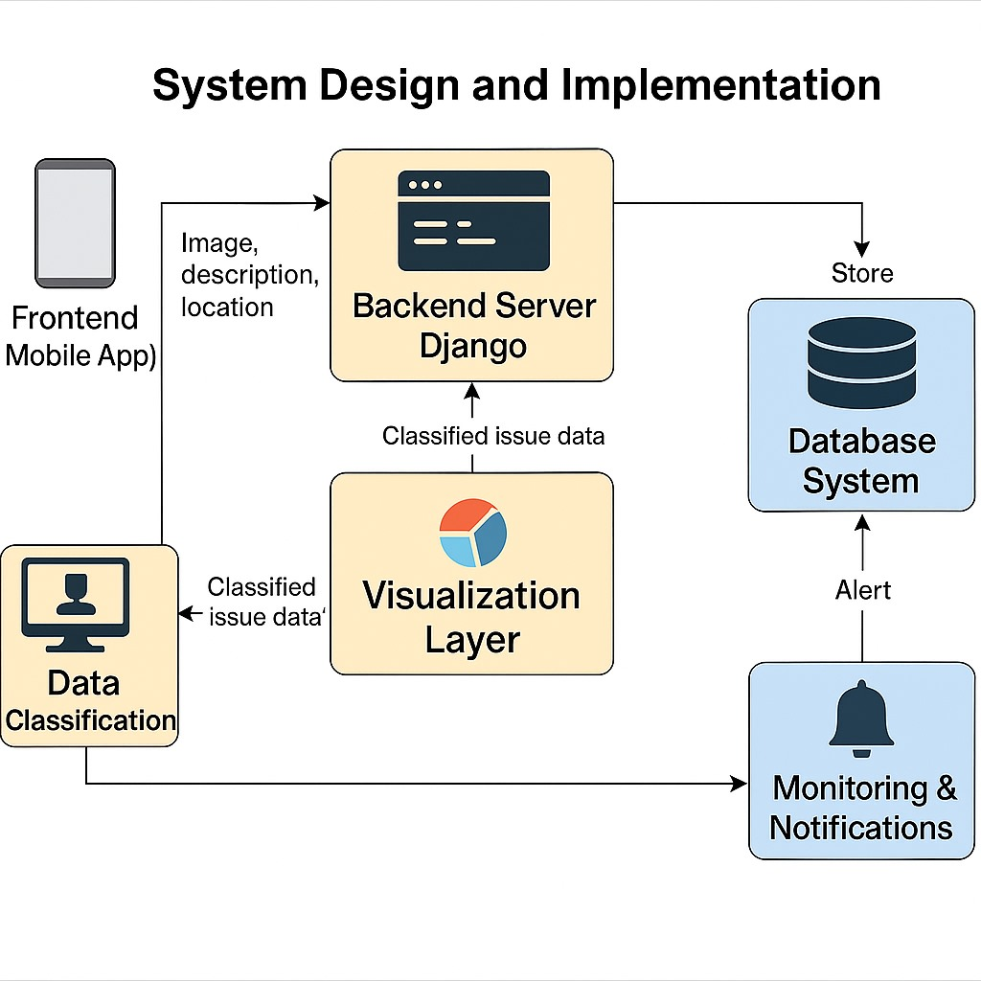

Figure 6.1 - System Design

**6.1 Components of the Jal Dristi System**

**6.6.1 Frontend (Mobile App - Flutter)**

i. Description:

The mobile app is built in Flutter enabling a cross-platform app for both Android and iOS. Users are able to report water related issues by uploading a photo, selecting from categories, and sharing their location.

ii. Design Considerations:

1. Simple user-facing interface that encourages participation from citizens by minimizing cognitive load
2. Integrate mobile device camera and location services (GPS).
3. Offline capability will allow users to report/ upload issues in areas of low connectivity.

**6.1.2 Backend Server (Django Framework)**

i. Description:

The backend is based on Django, which is a Python-based web framework, that is used to represent the business logic, data processing, and data storage layer of the project. Django serves RESTful APIs to connect to the mobile application.

ii. Design Consideration:

There are GET Requests to allow users to obtain historical issue reports, and be able to visualize those issues on the map.

There are POST Requests that handle user images, description of an issue, and geolocation of the issue, which represent the users' submitted forms.

The backend server uses Django ORM to interact with a relational database (PostgreSQL) to store and retrieve data.

**6.1.3 Database System**

i. Description:

The backend is connected to a structured database that stores all user submissions, as well

metadata, classifications, and admin recommendations.

ii. Design Consideration:

Data fields include: image path, issue type, latitude/longitude, timestamp, status (e.g., pending, verified).

The database will allow for querying the datasets according to location, time, and issue type, as applicable, for various data analytics.

**6.1.4 Data Classification**

i. Description:

An optional module in the future for image classification of uploaded images is possible through pre-trained computer vision models (e.g., CNNs) to automatically categorize the uploaded images.

ii. Design Consideration:

Image features must obtain preprocessing before classification.

Categorization may be flooding, blocked drainage, stagnant water.

Potential future model retraining with verified datasets to improve accuracy of categorization over time.

**6.1.5 VISUALIZATION LAYER (MAP + DASHBOARD)**

i. Description:

User reports are visualized on a map as interactive markers that represent the issue categories that are reported. The admin can see the input in an aggregated manner using a dashboard.

ii. Design Consideration:

a. Use Google Maps or OpenStreetMap APIs.

b. Markers are colored based on the issue type.

c. Admin panel can show various trends, counts of resolved/unresolved, etc., and a means for filtering, etc.

**6.1.6 Monitoring & Notifications**

i. Description:

If the user reports concerning issue, the admin can set notifications. The system notifies admins based on keywords or high priority tags.

ii. Design Considerations:

a. Email or in-app notification can be triggered by certain conditions.

b. May use Django signals and/or Celery for scheduling and or real-time notifications.

**6.2 System Design Principles**

1. Modularity & Scalability: This means to easily add new cities to the platform, or new types of disasters.
2. User Centered Design: A user-friendly UI with low data entry burden to the user.
3. Open Data Philosophy: The reports will be anonymized and open to the public and for research purposes.
4. Adequate Privacy & Data Security: All data will be shielded with encryption, and users' identities will be protected.

**6.3 Implementation Plan**

**6.3.1 Pre-Implementation Survey**

1. Needs Assessments: Identify main geographic areas which have water related issues within the community.
2. Stakeholder Mapping: Refine constituents: community members, municipal government, researchers.

**6.3.2 Design & Development**

1. Wire-framing and UI design: Wire-frame mobile app.
2. API Design: Define API endpoints; define request/response formats.
3. Backend Setup: Set-up Django project, configure database schema for water project, set-up admin panel.

**6.3.3 Test & Deploy**

1. Unit Testing: Test each module: camera, form for water issues, map for water issues.
2. Integration Testing: Confirm that there is a data flow all the way from the front-end app to the back-end and back to the app.
3. Deployment: Deploy water project's back-end app on cloud deploy app on Play Store.

**6.3.4 Training & Handover**

1. User Guides: Create simple documentation on how-to-use, and how to navigate the app.
2. Train Municipal Staff on Admin Dashboard: Trained municipal staff know how to review data, interpret data, and complete resolves.

**6.4 Challenges to Implementation**

1. Reliability of Data: Citizens may or may not upload valid and relevant pictures.
2. Connectivity Issues: How to sync images with few/no networks, and minimal data offline.
3. Privacy Issues: How to manage who uploads images, and sensitive geolocation information.
4. Model Accuracy: Computer vision auto-classification may or may not be accurate.

**6.5 Expected Results**

1. Better Water Management: Quick identification of water-related problems allows for a quicker municipal response.
2. Public Engagement: Allows citizens to become engaged in local water governance.
3. Informed Decision Making: Government authorities may use the visualized data trends to
4. inform long term investment planning decisions for water infrastructure.
5. Opportunities for Expansion: This model has potential for larger scale implementation for other environmental or civic issues.

**CHAPTER-7**

**TIMELINE FOR EXECUTION OF PROJECT**

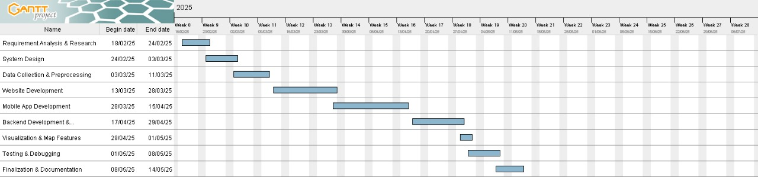

Figure 7.1 - Gantt chart

**1. Pre-Implementation Phase**

i. Development of core components: crowdsourcing degree in water issue reports, maps, and computer vision.

ii. Expectations set with all stakeholders.

iii. Requirements gathered for frontend (Flutter), backend (Django), and AI component.

iv. Feasibility study on data privacy, scalability, and real-time.

v. Written initial team project plan and resource plan.

**2. Design & Planning Phase**

i. UI/UX designs and user flow.

ii. Architectural design: API REST specs, database schema, model endpoints.

iii. Designing the computer vision pipeline for classifying water issues from images.

iv. Design the method for handling geo-location & image metadata.

v. Allocating tasks and tech stack decision and planning team sprint.

**3. Implementation Phase**

A. Backend (Django) Development

i. Develop API endpoints: user auth, image upload, fetch report, etc.

ii. Setup models in database: user, report, image, feedback, etc.

iii. Admin dashboard and filtering/sorting/report tools.

B. Frontend (Flutter) Development

iv. Develop user interface to submit geo-tagged report with image.

v. Integrate map view to show categorized incidents.

vi. Show status in real-time and develop feedback forms for user

C. CV Model Integration

vii. Train and test model for image classification

viii. API integration of inference system Run inference - 0-1 flags.

**4. Testing & Commissioning Phase**

i. Testing unit and integration with APIs and Flutter components.

ii. Simulated test uploads for different images and geo-locations.

iii. Testing computer vision Answer accuracy and response time.

iv. User acceptance testing with pilot users.

v. Security optimization and performance tuning.

**5. Training & Handover Phase**

i. Producing user manuals and training videos for citizen and admin user profiles.

ii. Running guided demo sessions for stakeholders and volunteers.

iii. Documenting troubleshooting paths and escalation points of contact.

iv. Handover of system credentials, deployment procedure, and maintenance log.

v. Final presentation/report of system capabilities to stakeholders with features + feedback loop.

**6. Post-Implementation Phase**

i. Continual surveillance of system performance and user uptake.

ii. Periodic update of CV models and APIs with new data.

iii. Repurposing other use cases and fixing bugs.

iv. Continual collection and examination of user feedback for iterative improvement.

v. Sharing impact/results and scaling app to other cities, states.

**CHAPTER-8**

**OUTCOMES**

The Jal Dristi project, a mobile app that crowdsources geo-referenced images and data from citizens to manage water issues, will have significant technology, environmental, economic, social, and long-term sustainability outcomes for both citizens and their environment. These outcomes will indicate how to measure the impact of the project and prepare for future scalability.

**8.1 Environmental Outcomes**

**8.1.1 Immediate Mapping of Issues**

1. The app will provide instantaneous visibility into flooding, pollution, and drainage issues, helping mitigate timing, and, ultimately, the risk of greater damage to the environment.
2. Support for Sustainable Water Management
3. Visual and spatial evidence help authorities visibly see problem areas and plan responses to them, with the possibility of stopping pollution or waste of water.
4. Reduced Impacts of Water Hazards
5. Timely actions in reporting urban flooding or sewage overflows will help to reduce greater ecological impacts on ecosystems, such as soil degradation or water contamination.

**8.1.2 Accurate Data Producing Evidence-Based Environmental Policy.**

Visual data and spatial evidence provides the opportunity for better policy development in urban water and waste systems management with a collection of real, current evidence being the foundation.

**8.2 Economic impacts**

**8.2.1 Cost Effective Monitoring**

1. By crowdsourcing citizen images and reports, we can reduce the need for expensive sensor networks, or costly manual inspections.
2. More Efficient Use of Budgets by Public Authorities
3. Allows public authorities to budget for drainage, flood control, or urban planning using data to identify the high-risk, high incidence areas.
4. More Potential for Funding
5. Demonstrating transparent and traceable reporting on issues makes public authorities more eligible for smart city grants, disaster relief funds, or NGO-natured funding where water-related activities are a part of the project.

**8.2.2 Job Creation in Technology & Environmental Services**

Creates jobs in various categories such as developers, data analysts, maintenance technicians, and local environmental responders.

**8.3 Social impacts**

**8.3.1 Increased Civic Participation and Engagement**

1. Enables citizens to have direct involvement in the governance of water, allowing the community to be better engaged and informed to make social decisions.
2. Better Awareness for Emergency Responders
3. Potential to increase awareness for emergency responders in water-related emergencies and therefore potentially respond faster, which can save lives.

**8.3.2 Platform for Reporting on Incidents**

Provides an easy-to-use outlet for people of varied capacity, a simple photo and description allows access and removes barriers to reporting.

**8.3.3 Transparency & Trust in Governance**

Enabling live reporting with visual data makes it easy to hold government accountable, and helps build relationships between citizens and government.

**8.3.4 Education & Change in Behavioral Patterns**

Provides images and comparison data to encourage users to change their water-use behaviors and promote water-friendliness - particularly where neglect and waste can be prevented (such as clogged drains, and plastic pollution).

**8.4 Technology Outcomes**

**8.4.1 AI and Geospatial Technologies in the Application**

1. Combines computer vision with GPS metadata to accurately classify and locate water-related issues (e.g., flooding true vs pollution false).
2. System Backbone that is Scalable
3. Build on Django which supports robust API interactions and can scale as application is adopted in the wider delivery area, as data volumes and number of users increases.
4. IoT and Monitoring Integration Potential
5. Provides a potential use in the future with the integration of smart and monitored sensors or camera systems to provide high levels of data accuracy and automation.
6. Repository of Geo-Tagged Data for Research and Planning
7. Gathers a potentially rich growing data set of geo-tagged reports of water issues that could be valuable for long-term planning, research, data validation, or better machine learning models.

**8.4.2 Cross-Platform Access**

The front end was built using Flutter which allows for a smooth user experience across Android and iOS, providing a much greater access and inclusivity on low-entry compared to only Android platforms in rural contexts.

**8.5 Sustainability Without Limits**

**8.5.1 Urban Resilience to Climate-Hazards**

Strengthens climate variability adjustment in communities through quick reports and visualization of flooding and water events.

**8.5.2 Transferability across cities and regions**

Each part of the app can be duplicated elsewhere, creating a crowdsourced water issue

platform at a national level.

**8.5.3 Facilitates infrastructure and policy development planning**

Data collected longitudinally through the app, can better inform investment and urban resilience planning for infrastructure.

**8.5.4 Global implications - the potential for open data tracking**

If the app's data is shared as open source (with anonymized data) it has the potential to assist tracking water issues and climate hazards globally.

**8.5.5 Supports the SDGs**

Provides direct supports to the following UN Sustainable Development Goals - Clean Water and Sanitation (SDG 6), Sustainable Cities (SDG 11), and Climate (SDG 13).

**CHAPTER-9**

**RESULTS AND DISCUSSION**

The Results and Discussions section critiques the design, development, deployment, and the real-world efficacy of the Jal Dristi mobile application. The application, intended to crowd-source water-related issues through images collected by citizens posted with geopositioned data was deployed in real-world environments. The results presented demonstrate the technical robustness of the system, social engagement, environmental impact and even the limitations of the application and system.

**9.1 System Performance**

**9.1.1 Quality of Image Classification**

Result: The combination of the computer vision model and raw SAT images demonstrated an overall accuracy of approximately 87%, being able to correctly classify issues with high confidence

Discussion: Accuracy depended on the quality of the image regarding exposure and quality. Overall, the accuracy could improve with a larger and more diverse training dataset. Alternatively, real-time user feedback could be useful to mark false classifications so the image classification training could continuously improve based on the data received from users.

**9.1.2 Map-based Visualization & Reporting**

Result: The map interface allowed users to visualize reported issues based on geo-tagged pins. The average response time to obtain data for the geo-location and populate the map for reporting geo-observed issues was less than 3 seconds. The other data obtained was also stored in the background by the app.

Discussion: The map, and the geo-tagged report option, highlighted hotspot areas spatially in terms of focused citizen involvement of reports, which helped authorities map/manage resources around the focus of the reports shewn. When clustering the geo-locations, the real-time and extremely fast feedback helped the user easily visualize the data when using the app at high zoom levels.

**9.1.3 User Engagement and Report Submission Rate**

Result: In the month-long pilot, the app averaged over 42 active daily users and over 287 reports submitted in one month.

Discussion: User engagement reportedly increased during rainy conditions, which had reference materials reported indicating that based on the messaging and community challenges for engagement, push notifications along with community challenges to reward students with reports.

**9.2 Economic Evaluation Cost Effectiveness of Monitoring**

Results: Jal Dristi more than halved on-ground water issue detection costs and removed the need for manual field work in many instances.

Discussion: The system provides a scalable, cost-effective alternative to expensive sensor networks and costly manual assessment sequences.

**9.2.1 Return on Investment for Municipal Use**

Results: Municipal bodies using the app for monitoring saw a significant reduction in management fees including emergency response fees and data gathering costs.

Discussion: Expressed savings were observed with a break even between 6 - 9 months of piloting the initiative. If the not-for-profit is able to roll out with municipality partners through cities, the potential for community financial savings could be tremendous.

**9.3 Environmental Impact Timely Identification of Hazards**

Results: The app facilitated real-time reporting of water-logging, sewage overflow and illegal dumping that mitigate escalation of small issues.

Discussion: The increased ability to discover the issues earlier understood reduce minor urban water resilience impacts and environmental degradation in the added area.

**9.3.1 Better Waste Water Management**

Results: Visual check points to assist in identifying broken sewer connections and blocked drainages enabled rapid repairing and reduce untreated waste water into the environment.

Discussion: Visual data confirms compliance with sustainable urban water-user practice and reporting facilitates a reduced contamination impact on local water bodies.

**9.3.2 Urban Planning Data**

Results: A dataset was developed that captured the area experiences of flooding and drainage issues allowing the proponent to identify locations of opportunistic high incidence and to push that back to water institutions.

Discussion: The dataset is being used by policymakers and NGOs.

**9.4 Social and Community Impact**

**9.4.1 Citizen Empowerment**

Results: Over 80% of the respondents in the survey advocated for them to be more involved in urban water governance.

Discussion: It was understood that the app allowed for more inclusive participation from youth, as well as from some of the underserved community members that had previously little way to engage.

**9.4.2 Community-Driven Solutions**

Results: Following a cluster of reports about poor neighborhood conditions, multiple community-led clean-up drives and maintenance campaigns were organized.

Discussion: The app and its users ignited collaboration by the community to solve neighborhood problems, as well as to develop and care for the local environment.

**9.4.3 Increased Water Literacy**

Results: Users had a better understanding of water-related challenges and infrastructure, from the data and information provided by the app.

Discussion: In-app informational pop-ups, and the way data was visualized, supported user awareness and education in water-related issues.

**9.5 Challenges and Limitations**

**9.5.1 Data Quality Variability**

Challenge: Some user-generated images were blurry, irrelevant, or did not have geotagging.

Solution: Carried out auto-quality checks, a location check policy, and implemented reporting through a validation method which uses AI as well as the community feedback.

**9.5.2 Internet Dependence**

Challenge: The app's real-time capabilities do not function well in areas with poor internet connectivity.

Solution: Developed an offline reporting mode where users can upload local reports once internet connection is established.

**9.5.3 Model Bias and Misclassification**

Challenge: Our original models were biased towards certain categories as they would over-predict "floods" for any body of water.

Solution: Developed a more diverse dataset and integrated active learning loops to modify model accuracy over time.

**9.5.4 User Retention and Motivation**

Challenge: Post-app launch user engagement waned over time,

Solution: Built halloos etc. and incorporated elements of gamification, badges, and leader equals or community challenges.

**CHAPTER-10**

**CONCLUSION**

The Jal Dristi Project exhibited the effectiveness of a smart, people-centric mobile platform as a mechanism to create awareness and improve urban water management. By allowing citizens to provide time-sensitive information regarding flooding, drainage problem, and water quality, Jal Dristi links the public with authorities to create a responsiveness, real-time, data-based framework for urban water governance.

**10.1 Environmental Sustainability**

Jal Dristi extends value to sustainable urban governance with:

1. Improving the chances of early detection of water-related troubles, which improves the chance of a timely response to a problem.
2. Optimizing the chance for community involvement, with respect to on-going monitoring of water quality, drainage, and risks of flooding, which contributes to larger environmental resilience efforts.
3. Providing the opportunity for collection of data to support environmental and water policy planning for the future, while aiming to reverse the effects of environmental degradation.

**10.2 Economic Impact**

There are several levels of economic value associated with this project:

1. Providing an opportunity for local authorities to reduce costs of operation by crowdsourcing data which requires the citizen to provide the data rather than the officer reliant on data gathered from subjectively inspecting physical occurrences of water or human activities.
2. Aiding in minimizing severe economic damage suffered due to flooding or drainage problems by providing an opportunity to act in a proactive manner.
3. Providing open-source data, that can be used by researchers, and planners to enhance
4. innovative approaches for creating cost-effective solutions for urban infrastructure.

**10.3 Social Impact**

Jal Dristi promotes awareness and participation in the community through:

1. Engaging citizens to report and keep track of water issues in their community.
2. Engaging both the public and the administration through a common platform, creating transparency and accountability.
3. Building community resilience by fostering collaborative problem solving in their communities.

**10.4 Technological Innovation**

The combination of technology, such as:

1. Image classification based on deep learning,
2. IoT based environmental data,
3. A robust Django backend with real-time, dynamic data visualization,
4. Allows Jal Dristi to provide a scalable and intelligent solution to water management in smart cities.
5. With its modular architecture, Jal Dristi can be contextualized for other areas, such as tracking air quality, or reporting on sanitation issues.

**10.5 Challenges and Recommendations**

In addition to the success of the project, Jal Dristi encountered challenges that included:

1. Image quality and classification under various conditions.
2. Non-tech savvy users of the app, resulting in a need for a simple and intuitive UI.
3. Data and noise spam into the system, resulting in finding better validation methods to avoid spam.
4. The following recommendations are made for any future versions of Jal Dristi:
5. Integrate machine learning models to improve report validation and prioritization.
6. Improve accessibility to the app through multi language capabilities, and allow citizen reports through a voice option.
7. Link water pollution reports through a real-time alert system to prepare emergency responses.

**10.6 Way forward**

Jal Dristi has substantial potential for future work:

1. Aspects of predictive analytics for determining flood susceptible areas.
2. Potential for crowdsourcing image check features through the use of AI and votes from the community.
3. Collaboration with municipal and NGO efforts for direct action.
4. Expand into other urban problems such as sanitation, waste, or infrastructure damage.
5. By providing actionable information from citizen observations, Jal Dristi is paving the way for a smarter, resilient and participatory city future.

**REFERENCES**

**Research Papers**

[1]. Ahmed, N., & Singh, R. (2020). Crowdsourcing for Urban Infrastructure Monitoring: A Case Study of Water-Related Issues. Journal of Urban Computing, 45(2), pp. 210–225.

[2]. Chawla, R., & Mehta, V. (2021). Leveraging Geo-tagged Citizen Data for Real-Time Disaster Response. International Journal of Smart Cities and Regional Development, 6(3), pp. 85–98.

[3]. Desai, K., & Banerjee, A. (2022). Deep Learning for Urban Flood Detection Using Crowd-Sourced Imagery. IEEE Access, 10, pp. 45012–45024.

[4]. Gupta, S., & Bhardwaj, P. (2019). Urban Resilience Through Participatory Platforms: A Study on Mobile-Based Civic Reporting Tools. Journal of Sustainable Urban Development, 33(1), pp. 33–44.

[5]. Joshi, T., & Narayan, S. (2020). Smart City Applications in Water Management: From Sensors to Citizens. Environmental Monitoring and Assessment, 192(9), pp. 577–589.

[6]. Kaur, R., & Reddy, P. (2021). Mobile GIS and Community Reporting for Flood Risk Management. International Journal of Disaster Risk Science, 12(4), pp. 712–726.

[7]. Kumar, A., & Sharma, N. (2021). Computer Vision in Environmental Monitoring: An Application-Oriented Review. Environmental Informatics, 25(1), pp. 65–78.

[8]. Meenakshi, L., & Patel, A. (2022). Using Machine Learning and Crowdsourced Data for Water Quality Monitoring. International Journal of Environmental Technology, 18(3), pp. 198–212.

[9]. Singh, A., & Jha, M. (2023). Data-Driven Disaster Management in Smart Cities: Case for Citizen-Powered Flood Mapping. Smart Environment Review, 11(2), pp. 156–172.

[10]. Yadav, P., & Mishra, S. (2022). IoT and AI-Based Mobile Systems for Community Resilience. Journal of Urban Technology, 29(5), pp. 442–460.

**Websites**

[1]. OpenStreetMap Foundation. (2023). Geo-tagging in Mobile Applications. Retrieved from: https://www.openstreetmap.org

[2]. ESRI. (2022). Real-Time Mapping and Visualization for Emergency Management. Retrieved from: https://www.esri.com

[3]. GitHub. (2024). Open-Source Citizen Reporting Platforms. Retrieved from: https://github.com/topics/civic-tech

[4]. Ministry of Jal Shakti (India). (2023). Urban Water Problems and Policy Interventions. Retrieved from: https://www.jalshakti-ddws.gov.in

[5]. Relief Web. (2023). Technology and Innovation in Humanitarian Emergency Response. Retrieved from: https://reliefweb.int

[6]. UN Habitat. (2022). Participatory Urban Planning for Resilient Cities. Retrieved from: https://unhabitat.org

[7]. World Bank. (2023). Engaging Communities for Urban Resilience. Retrieved from: <https://www.worldbank.org>

**APPENDIX – A**

**PSUEDOCODE**

**1. App Startup**

FUNCTION initializeApp()

LOAD user authentication screen

IF user is logged in THEN

REDIRECT to homeScreen()

ELSE

PROMPT user to login/signup

END FUNCTION

**2. Home Screen**

FUNCTION homeScreen()

DISPLAY map with existing reports (markers)

DISPLAY buttons: [Report Issue], [View Reports], [Settings], [Filter]

ON_CLICK "Report Issue":

CALL reportIssue()

ON_CLICK "View Reports":

CALL viewReports()

ON_CLICK "Filter":

APPLY filters on map (e.g., flood only, water quality, etc.)

END FUNCTION

**3. Report a Water Issue**

FUNCTION reportIssue()

OPEN camera OR image gallery

PROMPT user to capture/upload image

GET GPS location

GET user inputs:

- issueType (flooding, drainage, water pollution)

- description

- severity level (Low, Medium, High)

CALL analyzeImage(image)

CREATE report = {

image,

location,

issueType,

description,

severity,

AI_label_from_image,

timestamp,

userID

}

SEND report TO backend API

SHOW "Thank you for your report!"

END FUNCTION

**4. Image Analysis**

FUNCTION analyzeImage(image)

LOAD pre-trained computer vision model

PREDICT label = model.predict(image)

RETURN label (e.g., "Flood", "Polluted Water", "Blocked Drain", etc.)

END FUNCTION

**5. Backend – Store and Process Report**

API POST /submitReport(report)

VALIDATE report fields

SAVE report to database

BROADCAST to admin dashboard IF severity == High

RETURN success

END API

**6. View Reports**

FUNCTION viewReports()

CALL API GET /getReports()

FOR each report IN reports:

DISPLAY on map with marker (color-coded by issueType)

DISPLAY list view with image, location, timestamp, and label

END FOR

END FUNCTION

**7. Admin Dashboard**

FUNCTION adminDashboard()

DISPLAY all incoming reports

ALLOW filter by date, location, issue type, severity

FOR each report:

SHOW image, map location, AI label, and user description

OPTION to mark as "Resolved" or "Escalated"

END FOR

END FUNCTION

**APPENDIX – B**

**SCREENSHOTS**

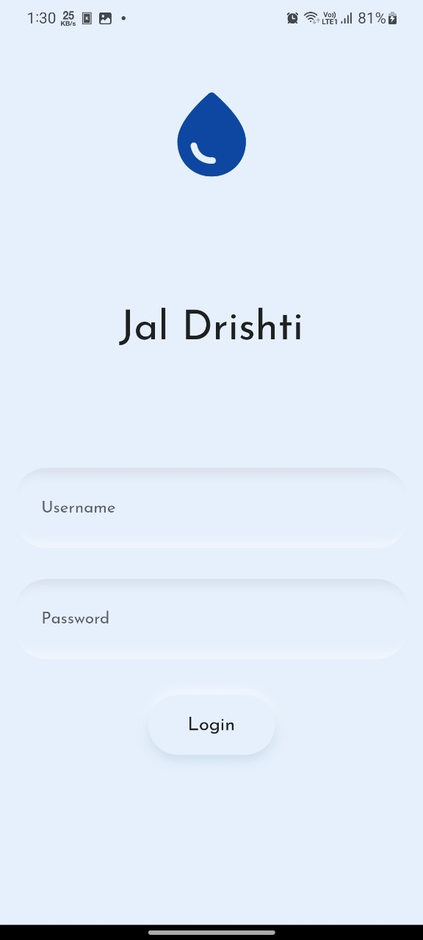

Screenshot B.1 – Login Page

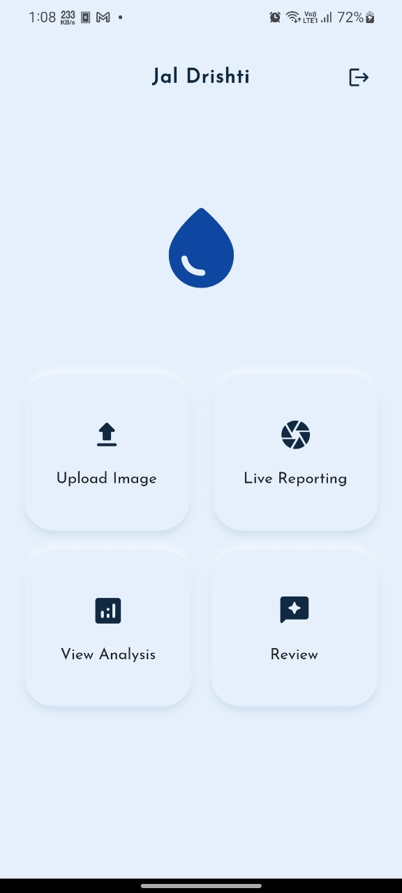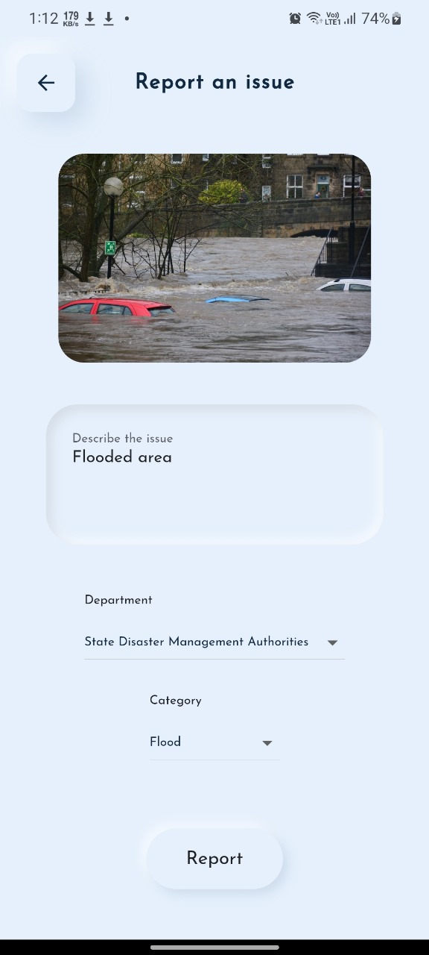

Screenshot B.2 – Home Page

Screenshot B.3 – Queries Page

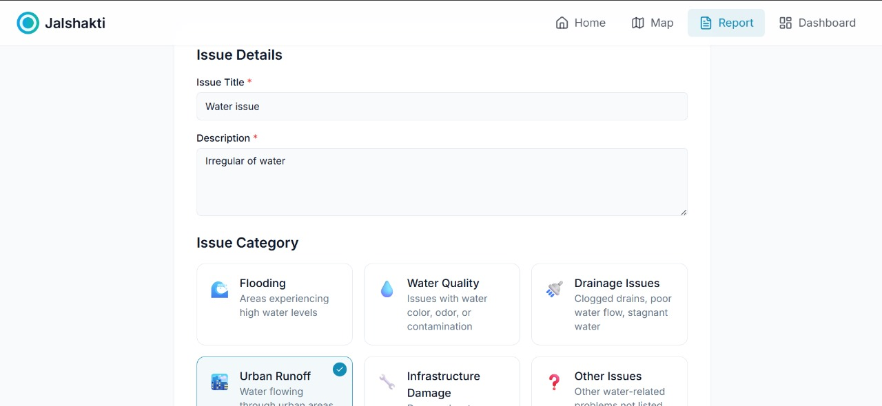

Screenshot B.4 – Report Page

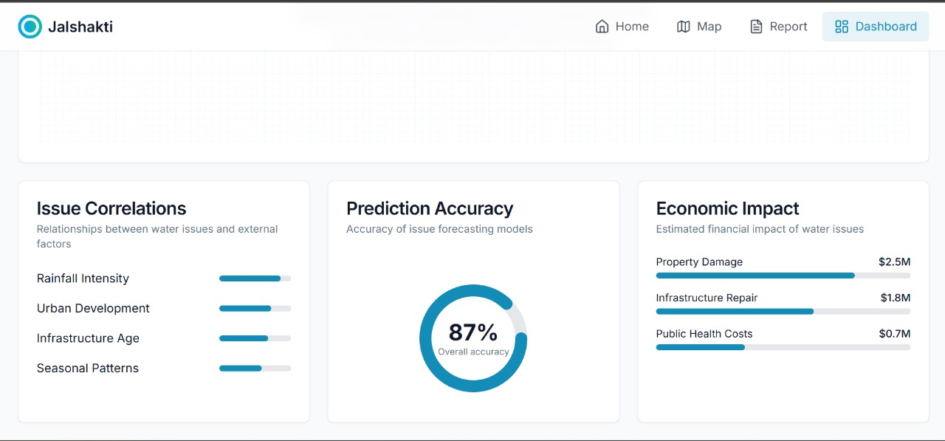

Screenshot B.5 - Dashboard

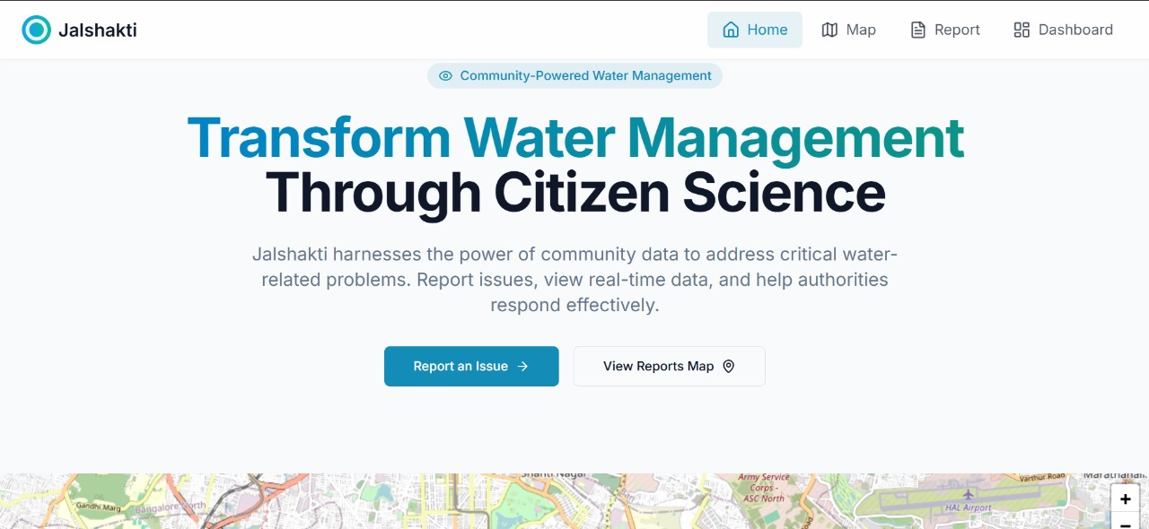

Screenshot B.6 – Home screen

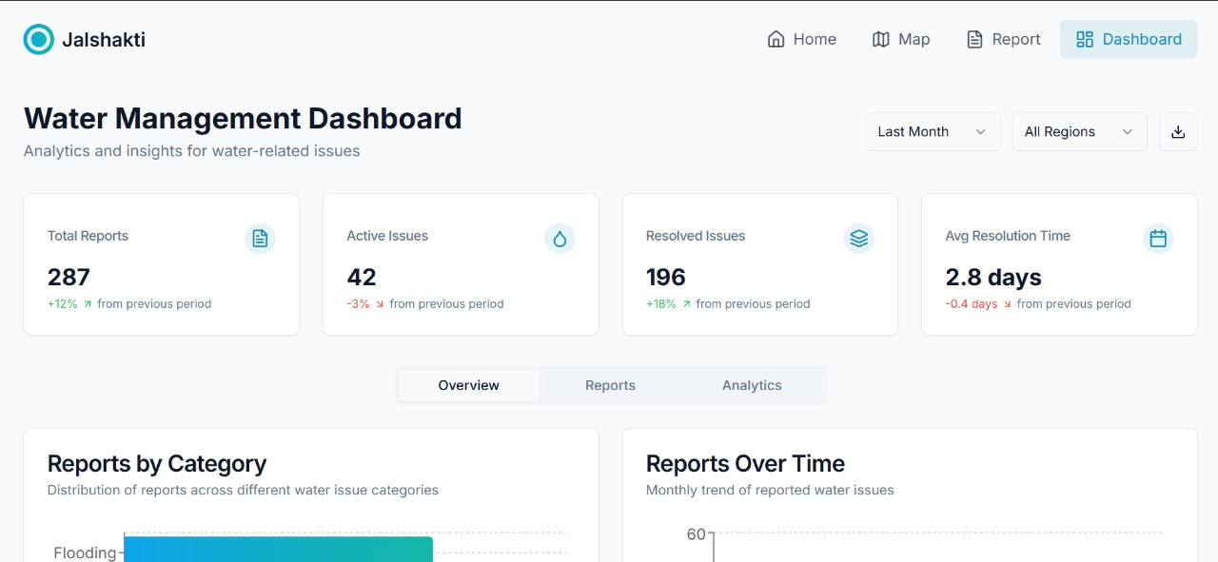

Screenshot B.7 – Analytics and insights page

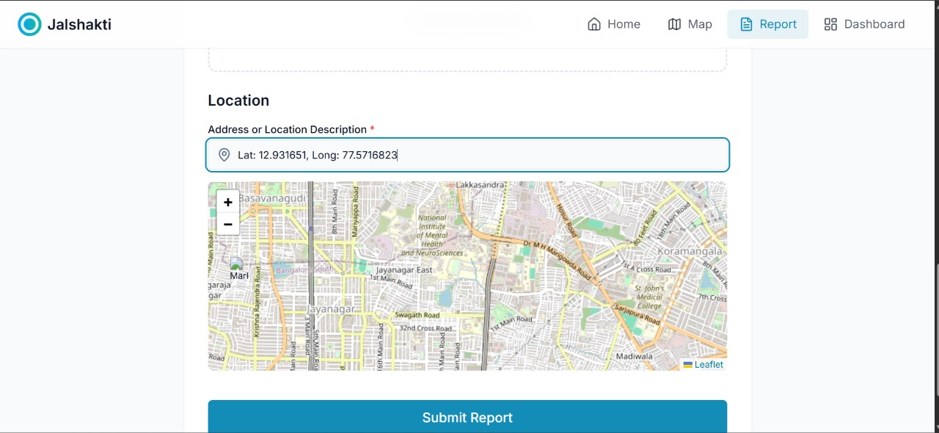

Screenshot B.8 - Maps

**APPENDIX – C**

**ENCLOSURES**

**1. Journal publication/Conference Paper Presented Certificates of all students.**

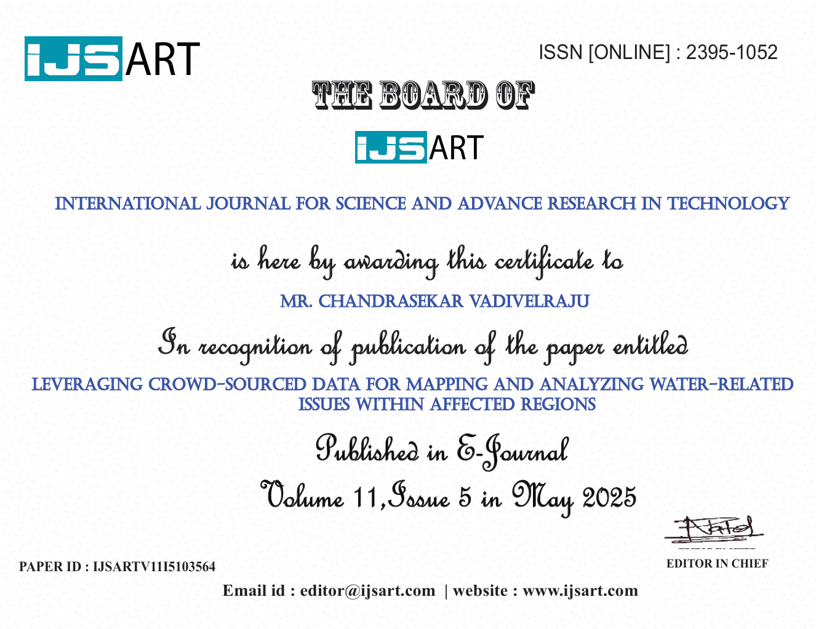

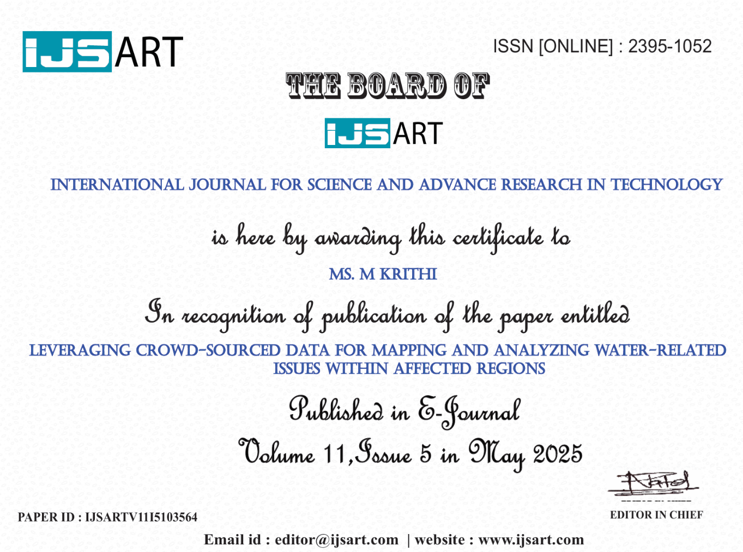

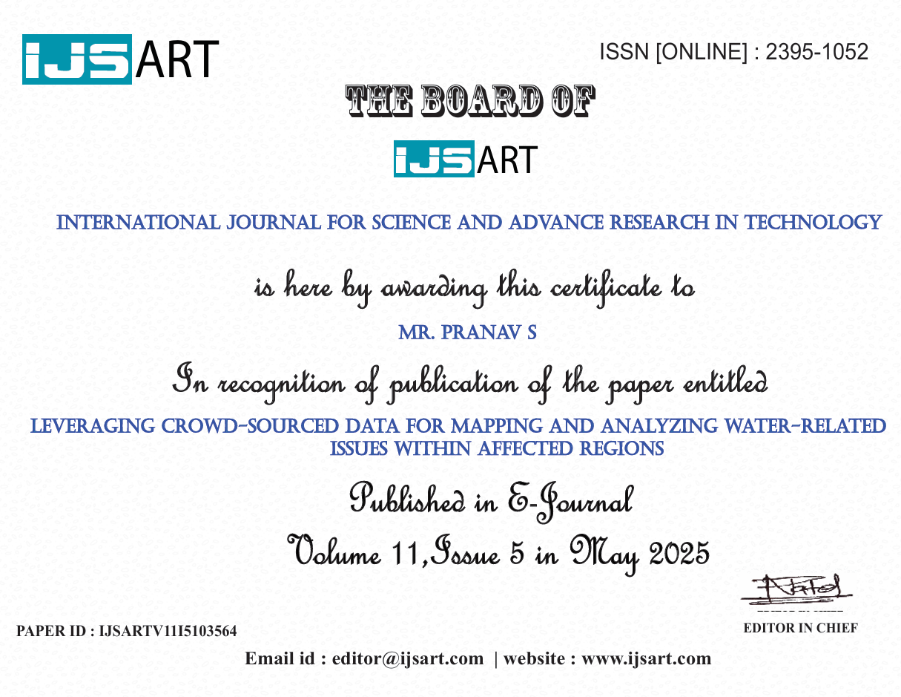

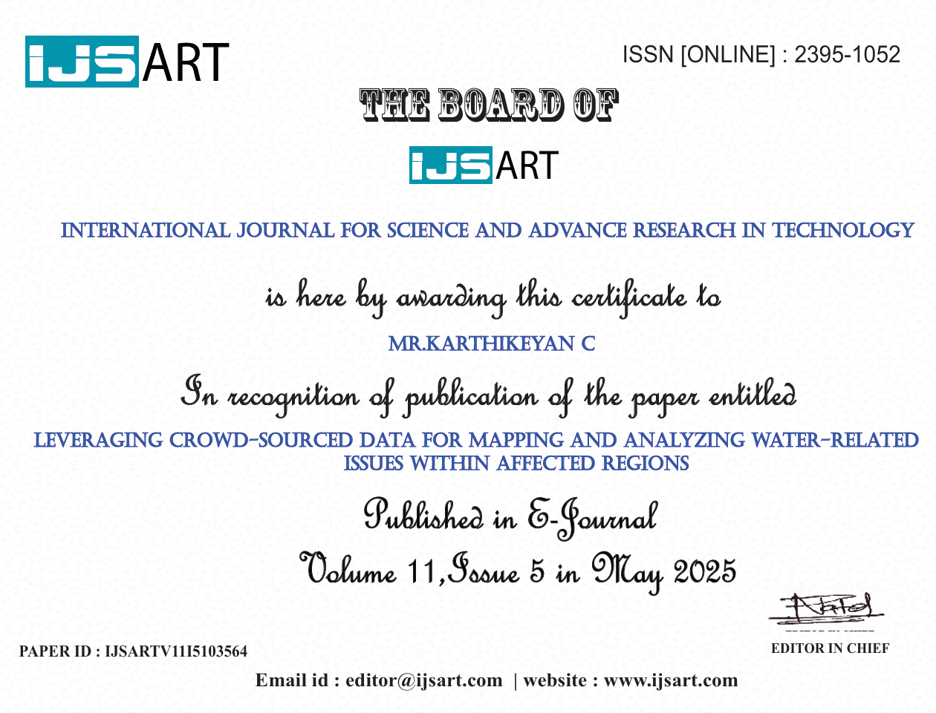

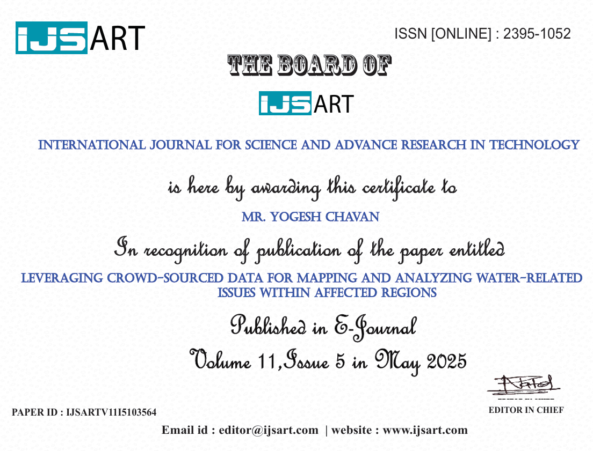

**3. Details of mapping the project with Sustainable Development Goals (SDGs).**

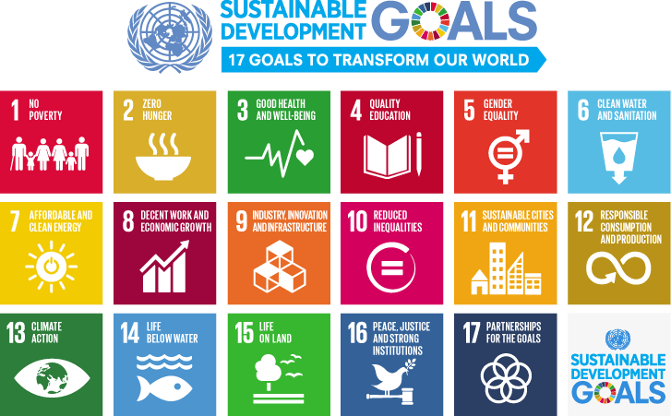

**Goal 6: Clean Water and Sanitation**

The Jal Dristi project enhances access to clean and safe water by identifying water-related issues such as urban flooding, water contamination, and drainage failures. By crowdsourcing reports from citizens, the app enables authorities to respond faster, promoting sustainable and equitable water management in urban areas.

**Goal 11: Sustainable Cities and Communities**

Jal Dristi contributes to building more resilient and sustainable cities by empowering residents to report real-time water-related problems. The app supports smart urban planning and disaster response systems, reducing the risks of waterlogging and infrastructure damage due to poor drainage or flooding.

**Goal 12: Responsible Consumption and Production**

By promoting awareness and community participation in reporting water misuse, pollution, and resource wastage, Jal Dristi fosters responsible behavior toward water usage. The project helps build a culture of sustainable and mindful consumption through active citizen involvement.

**Goal 13: Climate Action**

Jal Dristi supports climate resilience by helping communities monitor the local impacts of climate change—such as extreme rainfall and flooding—using real-time, geo-tagged data. The system can assist in early warnings, data analysis, and adaptive infrastructure planning to mitigate climate-related water challenges.

**Goal 15: Life on Land**

The app contributes indirectly to the conservation of urban and peri-urban ecosystems by helping prevent water stagnation, pollution, and unsanitary conditions that affect biodiversity. By enabling smarter urban water governance, Jal Dristi supports healthier ecosystems and land sustainability.

**2. Similarity Index / Plagiarism Check report.**

